Co-Chair  Vernon Sykes, Representative  34th House District | 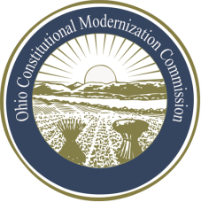 | Co-Chair  William G. Batchelder, Speaker  69th House District
Ohio Constitutional Modernization Commission

Report of the Coordinating Committee
July 11, 2013

The Coordinating Committee met in June and July 2013 to discuss the best approach for accomplishing its stated mission “to ensure that the Subject Matter Committees move forward on a timely basis with responses and viewpoints on proposals.” The Committee has resolved that it will need to have periodic reports from the Subject Matter Committees as to their progress and expected time frame for making recommendations. The Committee invited the chairs of the Subject Matter Committees to make a brief presentation at the August 8, 2013 committee meeting to inform the committee of their priority issues and work plans and timelines for reviewing those issues in 2013 and 2014.

The Committee also recommends that each of the Subject Matter Committees keep track of the following topics as they continue their deliberations: 1) issues that do not warrant constitutional revision but that the General Assembly may want to address statutorily, 2) obsolete provisions that should be eliminated from the Constitution, 3) language that would benefit from modernization. The Committee believes that information about obsolete provisions and outdated language should be noted and preserved so that it may be reported to the full Commission and General Assembly in order that they may consider whether some action to remove obsolete provisions and modernization language is appropriate.

The Committee believes that noting issues for potential legislative consideration, even though they do not fall within the scope of constitutional modernization, makes sense so that the Legislature and public will have the benefit of the Subject Matter Committees’ analysis of key points of Ohio law.

